**The Ark Documentation.**

**Biospecimen Custom Fields.**

Log in and select your study.

Once you have chosen your study we will see the following functions. Click the LIMS function in the top row.

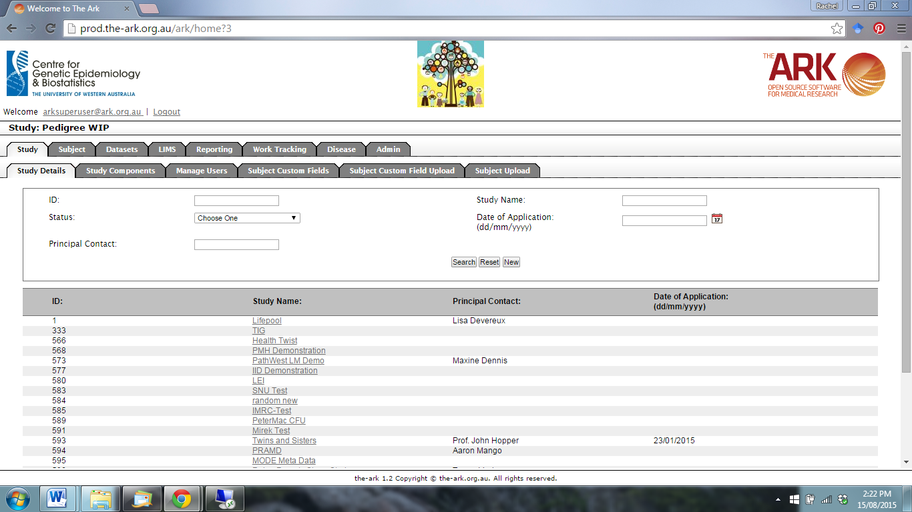

The following page will appear. Select the Biospecimen Custom Fields function.

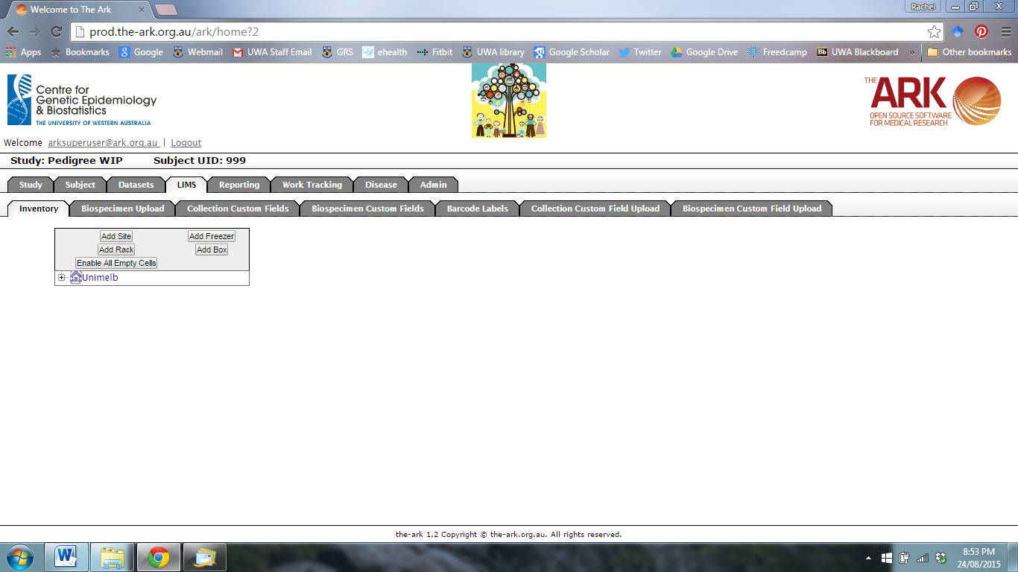

The following page will appear.

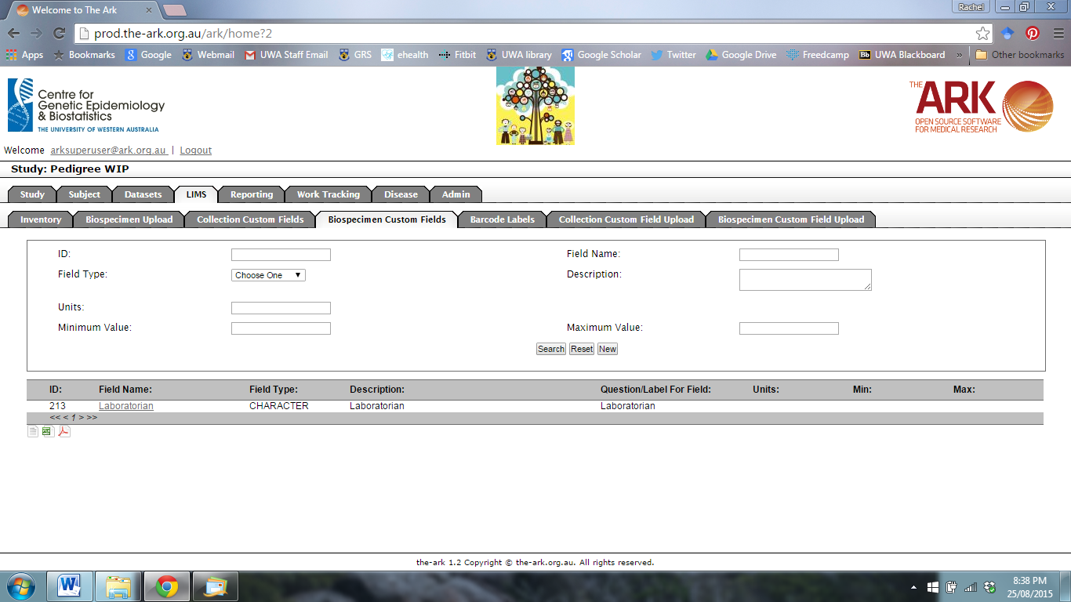

Select the Field Type from the drop-down menu.

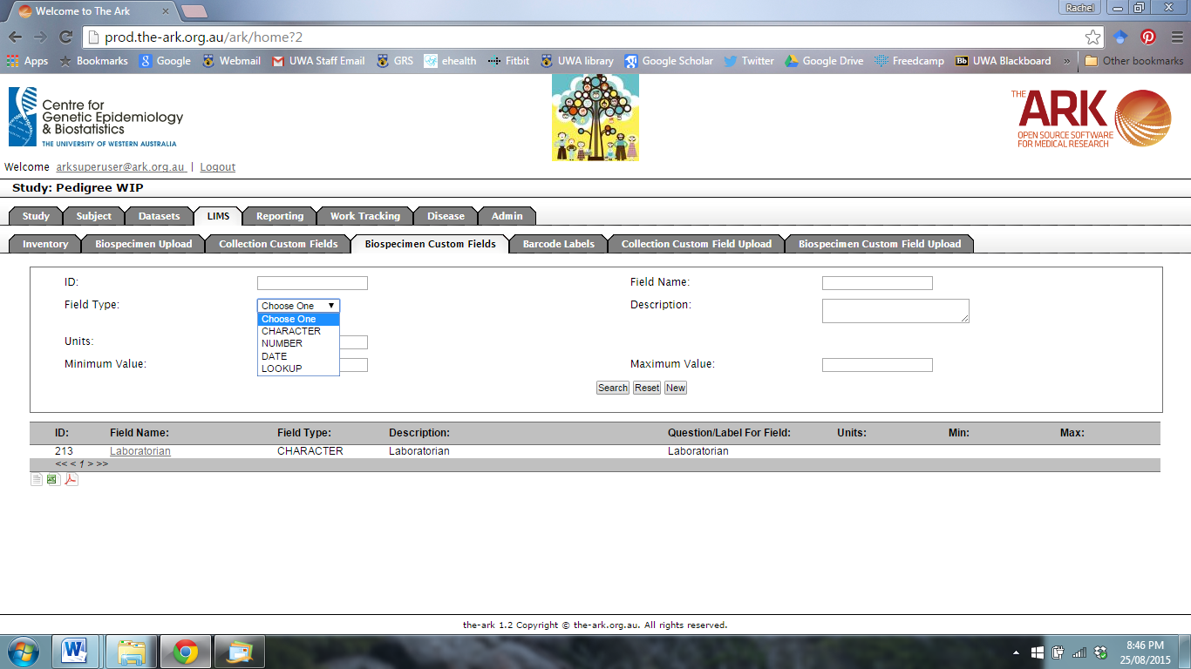

You can then enter the Field Name, Units, Minimum Value and Maximum Value. Click New to create a new Custom Field.

(Click Search to find an existing Custom Field, or Reset to start again.)

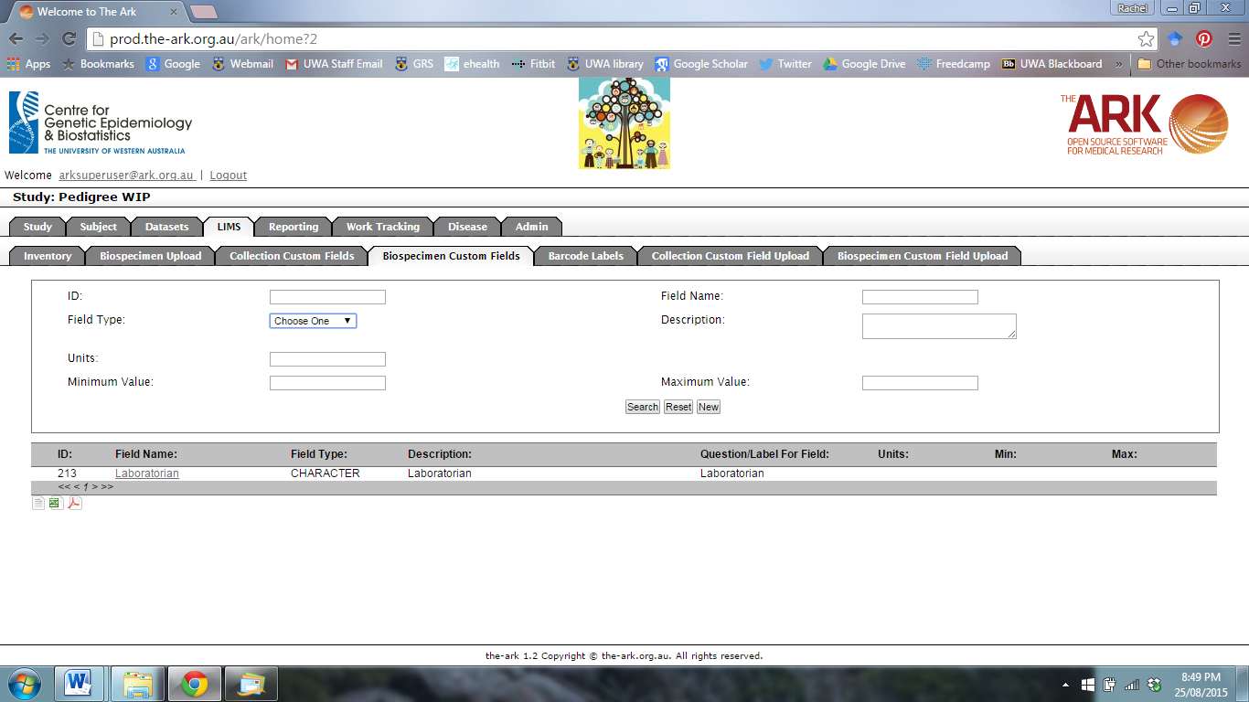

Once you have clicked New, the following page will appear.

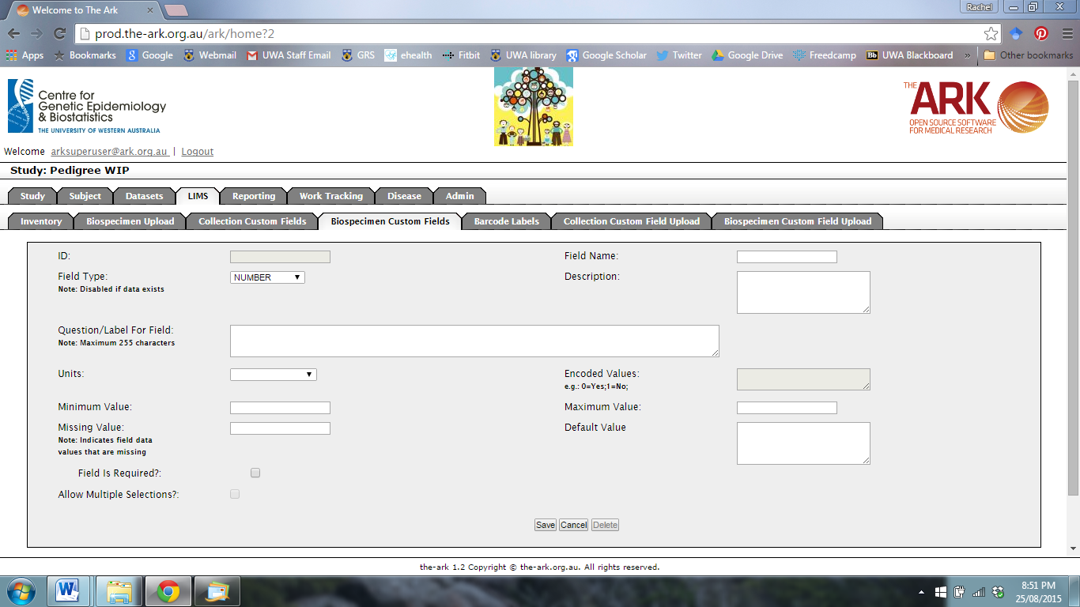

Use this page to fill in any additional information about the Custom Field. Then click Save.